proudly brought to you by:


George Hanna
george@ghanna.com.au

0413 484 667

Valuation vs Appraisal
Valuation, also known as a sworn valuation can only be conducted by a licensed Valuer who holds a relevant university qualification and has a separate registration and license. They charge a fee for their services and provide their valuation for various reasons (securing bank finance/loan, settling family and estate matters, addressing legal property issues and determining commercial leases). Buyers can engage them for an independent opinion as part of their own due diligence.

An appraisal is performed by a licensed Real Estate Agent or a registered Real Estate Representative operating under the Principal’s license. The purpose is to determine the sale price an agent believes they can achieve in the current market. A broad price range is provided to address the challenge of finding accurate comparable sales, potential uses, and urgency of the sale. Agents typically do not charge a fee for an appraisal.

Both, Valuers & Real Estate Agents use similar methods (estimated replacement value) to reach their conclusions. Quantity Surveyors & Builders can assist with providing an estimate of the replacement value for homes or any improvements on your property.

Generation Definition Explained
Pre-baby boomers: born before 1945 Baby boomers born 1946-1963
Gen X: born 1964-1981 Millennials: born 1982-1999

Gen Z: born 2000-2017 Gen Alpha: born after 2018
HOT, HOT, HOT!!!
Yes, now is the perfect time to SELL in this HOT Perth Market.
 Q&A
Q1) What is the mortgage cliff?
A1) There has been a lot of talk about the looming disaster presented by the mortgage cliff. The mortgage cliff refers to the sudden large increase in repayments that mortgage holders on fixed rate loans will face when their term ends and their loans revert to variable, and the subsequent effect it will have on the property market.
Q2) Are you in mortgage stress?
A2) Mortgage stress is defined as needing to pay more than one-third of your income in repayments. There are a few things you can do:

- Are you repaying more than the minimum on any loans (including your home loan) or credit cards, for example? If so, consider switching to minimum repayments with immediate effect.
- Are you, salary-sacrificing into your super? If you are suffering mortgage stress, this might be money that is more valuable to you now than in your retirement – stop salary-sacrificing.
- Are there any expensive kids’ activities or school fees that can be put on hold? If yes, put them on hold where feasible.

The next step is to contact your Bank, because Lenders are required to provide hardship assistance when needed. This could involve:
- A temporary pause in repayments,
- A restructuring of your loan, or
- Moving to interest only payments, which will take some of the sting out of your monthly mortgage bills, but please note: “Although your repayments will be lower, you will no longer be paying down any principal, which means that the loan will take longer to pay,”
- Re-financing, but ensure you shop around diligently, as you may end paying more to exit your existing loan and in establishing the new one.
Please seek financial advice and follow your own path

The particulars in this Newsletter are for information purposes only and shall not be taken as a representation in any respect on the agent as to the accuracy of any detail mentioned herein.

What is the RBA interest or 'cash' rate?
We constantly read and hear about the RBA's interest rate and how it will affect the economy, but how many of us know what it is?
The Reserve Bank of Australia (RBA) is Australia’s central bank and is a body corporate entirely owned by the Commonwealth of Australia. Its main role is to maintain the stability of the country's financial system.
Despite some common misconceptions, the RBA interest rate does not dictate the interest rates individual banks set for their loans (whether they are business loans, personal loans or home loans). Instead, the RBA interest rate is one which affects overnight loans in the money market.
How does this affect banks? Banks sometimes need to take out overnight loans (yes, the banks borrow from the reserve bank) to help fund their various transactions, and yes, banks sometimes run out of cash and that's why they take out overnight loans, which have an RBA interest rate.
So, a low RBA interest rate (sometimes called a 'cash rate'), in theory, drives further business by banks because they know that if they need to take out a loan to fund their own transactions, they won't have a large interest rate attached to it. If the cost of taking out a loan by a bank is low, then they are likely to take more risks through lending to more businesses and individuals, and this drives the circulation of money through the economy. Simple!
The cash rate is normally announced after each RBA board meeting, which usually occurs once a month (except January). This might change soon (the number of the board meetings may be reduced) as there’s a newly appointed Reserve Bank of Australia Governor.
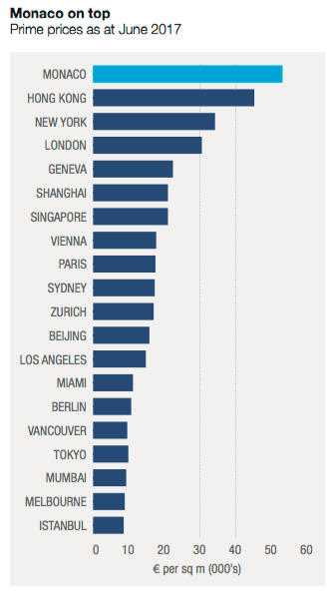
One Euro equals 1.55 Australian Dollar approximately (November 2017)

Yes, Now is the perfect time to

DID YOU KNOW
- Since August7th 2023, duplicate titles are no longer issued and have been removed from WA’s land system
- Anyone who has a Duplicate Title will not need to return it to Landgate, destroy it or have it rendered invalid as they will no longer have any legal effect

As we bid farewell 2023,

G Hanna Real Estate would like to take this opportunity to

thank all of you for your business and kindness throughout the year and wish everyone a very Merry

Christmas and a safe, happy and great Year ahead.

We look forward to continue

providing you with a quality service in 2024.

.

