George Hanna
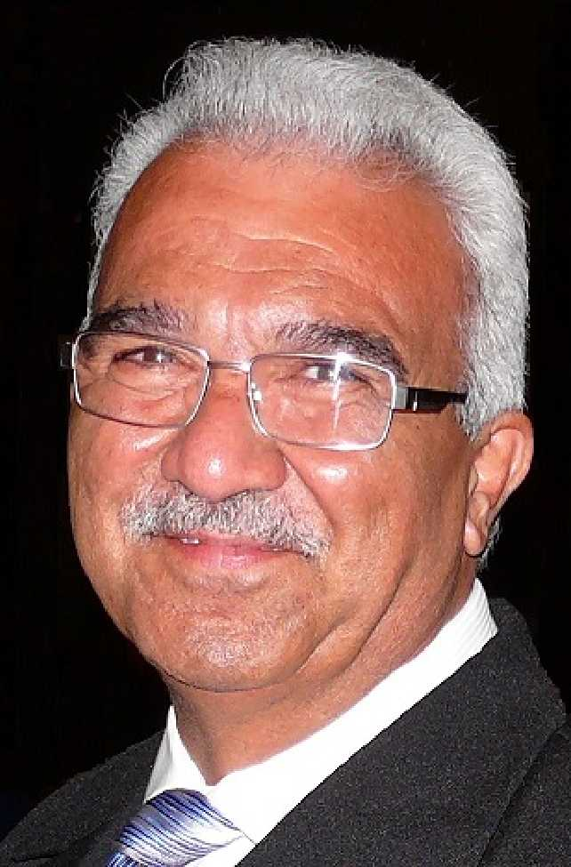
george@ghanna.com.au
0413 484 667

Encumbrances
An encumbrance is a registered interest in land by a person who is not the land owner, and any encumbrances on a property can usually be found listed on the Certificate of Title.
1. Easements
An easement is a common type of encumbrance that gives a person or company the right to use part of a property owned by someone else. For example, easements may allow gas, water, or sewerage to flow through the property, and are often granted to local councils, the Water Corporation, Western Power and Main Roads WA. You are restricted to build over them or near them. It’s a section of your land that you couldn’t utilize completely and limit your rights. (Please note that there is implied easement which are not always shown on the title. (Please note that there is implied easement which are not always shown on the title)
2. Memorials
A memorial is an encumbrance that places some form of notice or restriction on a property. For example, the property is in the noisy air traffic path or close to a kennel.
3. Restrictive covenants
A restrictive covenant places some type of restriction on the use of the land, such as restrictions on building material or on the size of the floor plan. Restrictive covenants are common in new developments, in which developers use restrictive covenants to ensure that properties maintain a level of uniformity for the new estate.
Real Estate Flipping
In a nutshell, it’s buying a property with the goal of renovating it and selling for a profit a short time afterwards. It’s common to read about investors using the 70% rule. This rule of thumb is used to determine what price to pay for a fix and flip to make money, i.e. the house flipper should pay 70% of the after-repair value (ARV) of a property, minus the cost of necessary repairs and improvements. As such, it can be a quick and simple way to determine a ballpark purchase price. You would make 30% profit, however, remember that closing costs (including capital gains), lender fees, mortgage ...etc. factor into that 30%
Another year down...what a year it was!!

All-in-all, “the WA market has outperformed in a major way
 Q&A

Q: I put an offer in on a property but I've seen another home I like better. Can I withdraw my offer?
A: Yes, as long as the offer hasn't been accepted. The contract is not legally binding until the seller has accepted and signed.

Q: What if I change my mind about buying a house after the offer has been accepted but before I've paid the deposit? Is the contract still binding?
A: Once both parties have signed the contract, you are legally bound to its terms. In Western Australia, property contracts do not include a cooling-off period.
We recommend seeking legal advice to ensure you fully understand your obligations and any potential consequences.

Q: I've sold my home, why is another inspection needed before settlement?
A: The purpose of the pre-settlement inspection is for the buyer to confirm that everything advertised with the property, is still present. This may include fixtures such as a dishwasher, or other features advertised at the time of sale and agreed upon as part of the purchase.

Q: Can I make an offer on a property that is already 'under offer/under contract'?
A: If a property is under offer, you can't make an official offer, but you can express interest to the agent. If the initial deal falls through, they may approach you.
However, if the original offer is subject to the sale of the buyer's own property with a 48-hour clause in the contract, and the seller receives another acceptable offer during this period, the initial buyer has 48 hours to either waive the 'subject to sale' clause or void the contract. This would enable the seller to accept another offer.

Q: An agent is saying they will not present my offer to the seller. I thought they had to present all offers, no matter what?

A: That is not necessarily the case. If a seller has told their agent that they will not entertain a certain price point, or will not accept any offers before a certain date (e.g. home open or set date sale), the agent is obligated to follow the seller’s instructions

Top questions to ask before moving to a new suburb
Is it safe?
You can gauge safety by looking into different crime statistics for a particular postcode
Visit the suburb at night time to see if the public spaces and streets are well lit and in the weekend to gauge the activities

Is it noisy?
Check the streets surrounding the property you’re considering on Google Maps to see if there are any noisy facilities, services or public works close by
things to watch out for could include schools, freeways, tips, train lines, bus routes, shopping centers, airports, race tracks, sports arenas, industrial areas, concert halls, nightclubs and live music venues.
take a look at the council’s website to see if there are any major infrastructure or redevelopment projects close to the property that may be noisy and impact traffic conditions down the track.

Is there a good community spirit?
If you value friendliness, supportive neighbors and want to get involved in community programs, then this is something you will want to spend a bit of time evaluating.

Will I be happy there?
If you’re a foodie, you’ll want to check out the local brunch scene, visit the bakery, sample the coffee and see what’s available on UberEATS before moving in.

Is it pet-friendly?
If you’re looking at inland suburbs, you will want to check whether the local parks and walking trails allow for dogs. See if there are any designated off-leash dog areas so your dog can easily socialize with other dogs, enjoy a game of fetch and burn off excess energy running around freely.

Can I afford it?
factoring in all your monthly expenses like groceries, eating out, internet, fitness, utilities, subscriptions, transport, childcare, school fees, rates and the mortgage/rent to ensure your planned move is feasible in the long-term.
Yes,

As we bid farewell 2024,

G Hanna Real Estate would like to take this opportunity to

thank all of you for your business and kindness throughout the year and wish everyone a very Merry

Christmas and a safe, happy and great Year ahead.

We look forward to continue

providing you with a quality service in 2025.

.
DO YOU KNOW
“All mistakes are good mistakes, provided they’re new ones. If you are making new mistakes, it means you are trying things you haven’t tried before. This is progress."

